REV. | Description | Date
00 | SPEC ISSUE (NEW MODEL)  ADP-330DB BA | 04/15’21
01 | 102A-215164  Add item 9.9 Acoustic noise test frequency use full frequency  102A-215191  ADD MODEL: ADP-330DB BA1 | 05/28’21
02 | 102A-217148  Remark Active PFC and common mode noise setup test condition | 07/21’21
03 | 102A-219037  ADD MODEL: ADP-330DB BA2 | 09/07’21
04 | 102A-21A168  Add 3.I Abnormal test remark | 10/22’21
05 | 102A-21C258  UPDATE ITEM 9.6 EMI, ITEM 9.7 RFI | 01/04’22
06 | 102A-221088  ADD MODEL: ADP-330DB BA8 | 01/17’22
07 | 102A-222005  UPDATE ITEM 6 Test Item: Pin at No Load, Pin at standby Load (follow ES SPEC and fix remark)  UPDATE ITEM 9.6 EMI, 9.7 RFI (fix remark) | 02/08’22

FOR MODEL:
ADP-330DB BA | ADP-330DB BA1 | ADP-330DB BA2 | ADP-330DB BA8
- 測試注意事項內容，未經工程師許可，不可任意變更。
Test Notice contents shall not be changed or revised without engineer permission.
- 此測試規格用於主線測試,所有項目均需被測試,因設備或線速限制無法全數測試時, 需測試worst case, QC需按抽樣標準做抽樣測試.
The production line shall perform all or worst test items/conditions, and QC shall follow the sampling plan to perform the sampling test
- 測試注意事項 :
  - 所有ATS測試時，需偵測CONNECTOR端之電壓。
  - EMI 測試需熱機30分鐘.
  - 測試轉接頭需並聯100uF/50V and 0.1uF(小黃豆), 限用日系電容.
  - 測試function用的製具板,Vo與PSID間不用接電阻,而PSID與GND間須接一顆開關,線路如下所示.除了測試OCP LEVEL1外,此開關均切在ON的位置.
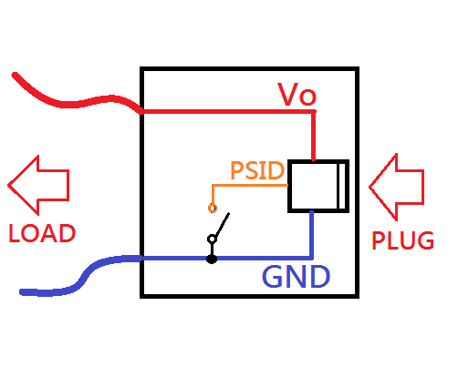
  - EMI/RFI/ESD/Burn in用製具板.GND與PSID間須短路,讓ADAPTER OCP切在LEVEL2才能抽到滿載.
  - 由於ADAPTER POWER ON後再Plug in,會需要判斷Pull low時間需落在800us~1ms間才能將OCP切在LEVEL2.所以測試前須先將製具板Plug in好再Power on.
  - 如要重新拔插製具板,須斷電並將輸出放電後再重新插入,避免OCP被設定在LEVEL1導致無法抽滿載.
  - Full Function test，電子負載需設定Von點15V (base on ADP-240GB BA)
  - Abnormal test Base on abnormal test adapter should be protection auto or latch and no safety issue.
- 燒錄IC :
- Firmware燒錄
此機種無須燒錄Firmware.
- PSID燒錄
    - 此機種需燒錄PSID,於流完線貼完LABEL後燒錄.
    - 燒錄IC之Location Name=IC103, IC種類如下表格勾選:
選取 | DELTA P/N | Description | Vender P/N | Vender
V | 2610711008 | IC MCU OTP 1K TO-92-3P | BQ2022ALPR | TEXAS INSTRUMENTS
V | 2610711108 | IC MCU OTP 1K SOT-23-3P SMD | BQ2022ADBZR | TEXAS INSTRUMENTS
 | 2610560052 | IC EPROM 512 120uS TO-92-3P | DS2501+T&R | MAXIM INTEGRATED
 | 2610560152 | IC EPROM 512 120uS SOT-23-3P SMD | DS2501R+T&R | MAXIM INTEGRATED
V | 261071112G | IC MCU OTP 1K SOT-23-3P SMD | OB1022MDP | On-Bright Electronics
 | 2640522900 | IC XX2510000021+90W_QCI SMD | MAX28500GSA-W21+2T | MAXIM INTEGRATED
 | 2640522800 | IC XX2510000021+65W_QCI SMD | MAX28500GSA-W21+1T | MAXIM INTEGRATED
 | XX2510000021 | IC ADAPTER MONITOR SO-8P SMD | MAX28500GSA+T | MAXIM INTEGRATED
*請於選取欄Key in "V"以代表選取.
    - EE需編輯燒錄檔INI上傳SAP申請料號,並將料號附加於BOM表中.產線作業人員得於上線前按照BOM表所列之料號於PLM下載燒錄檔INI以進行燒錄作業.燒錄檔內容如下表格所示:
MODEL | 起始码 | DELL P/N | Family code | INI File  (5060340700為INI檔的十碼料號,須與BOM相符)
ADP-330DB BA/BA1/BA2/BA8 | DELL00AC330195169 | 5P90C | E05 | [Model]  1 =5060340700,1  [Parameter]  1 = DELL00AC330195169,1  [Customer]  1 = 5P90C,1  [Family]  1 = E05

    - 燒錄內容規則與範例如下表格說明:

Table Contents of ID Chip
The contents of the ID memory chip are described in the table below.
Field | Byte Length | Byte Offset | Example
Header | 4 | 00h | DELL
Revision Number | 2 | 04h | 00
Class of Product | 5 | 06h | AC330
Output Voltage | 3 | 0Bh | 195
Output current | 3 | 0Eh | 169
PPID & Model Rev | 23 | 11h | ***********************  (See Barcode Printing Format
Checksum | 2 | 28h | [**][**]  (See below table description)
Family Code | 3 | 2Ah | E05
Total | 45

EXAMPLE OF CONTENTS
DELL | 00 | AC330 | 195 | 169 | *********************** | [**][**] | E05
↓ | ↓ | ↓ | ↓ | ↓ | ↓ | ↓ | ↓
Header | Revision Number | Class of Product | Output Voltage | Output current | PPID & Model Rev | Checksum | Family Code
Note that there will be no spaces in between the characters. The spaces shown are for clarification purposes only.

Field | Description
Header | The header shall be four ASCII characters, which will be DELL.  標頭必須是四個ASCII字符"DELL"
Revision Number | Two ASCII characters, which represent the code revision number. This will enable Dell to keep track of the contents of BQ2022 after it has been revised. Initially the code revision number will be 00. Should the data that is programmed on the BQ2022 IC be revised then the code revision number will be updated accordingly.  此區為兩個ASCII字符,此區代表燒錄內容修訂的版本代碼.主要是為了讓Dell在修訂燒錄內容後能夠對其進行跟踪.最初代碼修訂版號為"00".如果之後對燒錄內容有變更,則版本代碼將進行相應的更新。
Class of Product | Five ASCII characters assigned by DELL to identify the product. The first two characters will identify the product type followed by the nominal output power of the product. The first two characters will be AC for all adapters. For power supplies the first two characters will be PS. In the event that the nominal output power is two characters, a zero shall be used to fill the third character.  DELL分配了五個ASCII字符來標識產品類型與功率.前兩個字符標識產品類型,後跟產品的標稱輸出功率.對於所有的Adapter而言,前兩個字符均為"AC"。對電源供應器而言,前兩個字符為"PS".如果標稱輸出功率是兩個字符,則應使用"0"填充第三個字符,如65W的Adapter,應標為"AC065";如為240W的Adapter應標為"AC240".
Output Voltage | Three ASCII characters that provides the nominal output voltage of the product. It will be assumed that the last digit represent a tenth of a volt. For example 195 will represent 19.5V and 125 will represent 12.5V.  標示輸出電壓的三個ASCII字符.其中前兩位為整數位,而最後一位代表小數第一位.例如19.5V應標示為"195"，而12.5V應標示為"125".
Output current | Three ASCII characters that provides the full load continuous current of the product. It will be assumed that the last digit is a tenth of an amp. For example 145 will represent 14.5A. In the event that the full load output current is two characters, a zero shall be used to fill the first character e.g. 025 will represent 2.5A. If the output current is for example 9.23A then the three ASCII characters for this field will be 092, thus the full load continuous current will have to be correct to the first decimal.  標示滿載輸出電流的三個ASCII字符.其中前兩位為整數位,而最後一位代表小數第一位. 例如"145"代表14.5A,如果滿載輸出電流是兩個字符則應使用"0"來填充第一個字符,例如"025"代表2.5A.例如,輸出電流為9.23A則此字段的三個ASCII字符將為"092".因此滿載連續電流必須正確標示到小數點第一位.
PPID & Model Rev | 23 Digit Bar code that will contain the country of Origin ISO code, DELL Part Number, supplier identification code, date of manufacture, unique sequence number and part revision. See below for detail explanation.  標示來自LABEL條碼的23個ASCII字符,其中包含產地ISO代碼/DELL part number/Vender識別碼/生產日期/唯一序列號/零件版本.範例共列了23個*,每個*可為0~9或A~Z的任一字,全部取決於條碼資訊的資訊.  有關條碼的格式與資訊請參考DELTA DOC:10000-0173-3d
Checksum | Two bytes checksum. CRC will be used to verify that the data transmitted to the ID chip and read from it, is correct. The CRC will be generated using the polynomial X^16 + X^15 + X^2 + 1.  標示check sum的兩個字節.CRC用於驗證傳輸到ID芯片並從中讀取的數據是否正確.此CRC使用多項式X ^ 16 + X ^ 15 + X ^ 2 +1生成.由於此兩字節無法以ASCII字符顯示,故以一個括號[ ]來代表一個字節.而括號中的*為0~9或A~F的任一字,一個括號內應有兩個0~9或A~F的任一字,全看CRC的計算結果.另外,第一字節應為CRC計算的低位數,第二字節應為CRC計算的高位數.例如:  燒錄內容"DELL00AC240195123CN0RYJJ9DES009C10001A02",CRC計算結果為81B2,則應標示為"[B2][81]"  燒錄內容"DELL00AC330195169CN0GMT0MDES009C10001A01",CRC計算結果為0F70,則應標示為"[70][0F]"  CRC計算請參考"https://crccalc.com/"中的"CRC-16/ARC".
Family Code  (僅部分機種適用) | For some models, three ASCII characters assigned by DELL to identify the product of family. For E4 series the three characters will be "E04"or"E4A". For E5 series the three characters will be "E05". If the family code have no define of spec, the system will default to E4 series.  對部分機種來說DELL分配了三個ASCII字符來標識系列產品,對於E4系列,三個字符將是“ E04”或"E4A".對於E5系列,三個字符為“ E05”.如機種規格未定義Family code,則系統端將直接認定為E4系列.

- 手調測試站：
  - Full Load Test: 檢查滿載輸出是否符合規格
  - Min. Load Test: 檢查輕載輸出是否符合規格
  - OVP Test :
Load Condition : 19.5V/Full load
測試方法: Short R145檢查輸出電壓是否介於21.2V~25V, OVP動作模式為Latch mode .
  - OTP Test :
Load Condition : 19.5V/Full load
測試方法: 10K並聯NTC30,檢查輸出電壓是否Latch off.
  - LED狀態:
Power supply 開機後LED必須亮燈, 關機後LED 會自動熄滅。
  - AC On/Off:
Power supply 連續開關機 On= 5秒, Off= 1 秒, 5 次後, 必須無損壞情形。
測試時electronic load須設定Von=15V.
  - Loop gain:
由R131該20ohm電阻進行loop gain之量測.線路如下所示(擾動電壓1.7V)
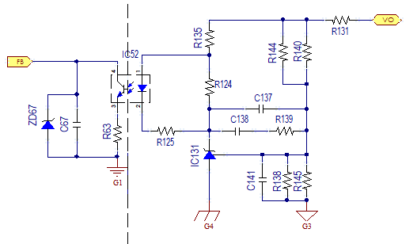
- Function test (ATS) procedure：
Input Specification Table:
INPUT VOLTAGE | MINIMUM | MAXIMUM | NOMINAL(RATED)
LOW RANGE | 90 VAC | 132 VAC | 100 VAC
HIGH RANGE | 180V AC | 264V AC | 240V AC
Output Specification Table:
OUTPUT | MINIMUM | MAXIMUM | NOMINAL(RATED)
Voltage (Vdc) | 18.5 | 20.5 | 19.5
Loading (Amp)  AMB=0~40degC | 0 | 16.92 | 16.92

Test Item | Vin | Load | Spec | Remark
Inrush Current | 264V/50Hz;  Phase 90º | 19.5V/Full load | < 200A  < 250A | AC source 3~4KVA  AC source 9KVA  Cold start  Base on<22% I^2t of Fuse spec
Switch On Time | 90V/50Hz | 19.5V/Full load | <4Sec | 在系統輸出增加0.1uF//100uF
LED turn on | 90V/50Hz | 19.5V/ Full load | <4Sec | 在系統輸出增加0.1uF//100uF
Hold up time | 100vac/50Hz | 50% | 8ms | 50%Load, 100Vac Vo within regulation
Rise Time | 90V/50Hz | 19.5V/ Full load | 2~100mS | From 10 to 90% voltage, monotonic
Line Regulation | 90/180/264V 47/63Hz | 19.5V/0A | 18.5~20.5V | 需量測cable end電壓
Line Regulation | 90/180/264V 47/63Hz | 19.5V/ Full load | 18.5~20.5V | 需量測cable end電壓
Load/Combine  Regulation | 90V/264V  47/63Hz | 19.5V-0A, Half load, Full load | 18.5~20.5V | 需量測cable end電壓
Ripple & Noise | 90V/47Hz | 19.5V/ Full load | <350mVp-p | 在系統輸出增加0.1uF//100uF
Ripple & Noise | 264V/63Hz | 19.5V/ Full load | <350mVp-p | 在系統輸出增加0.1uF//100uF
Sync Dynamic | 90V/50Hz | 19.5V/0A ~ 0.85* Full load | 18~21V | S/R:2.5A/uS, 50Hz/100Hz/1KHz/10KHz  在系統輸出增加0.1uF//100uF需量測cable end電壓
Sync Dynamic | 264V/50Hz | 19.5V/0A ~ 0.85* Full load | 18~21V | S/R:2.5A/uS, 50Hz/100Hz/1KHz/10KHz  在系統輸出增加0.1uF//100uF需量測cable end電壓
Short Circuit  Protection | 90V/60Hz | Output load 0 ohm Turn on then short | Latch off
Short Circuit  Protection | 264V/50Hz | Output load 0 ohm Turn on then short | Latch off
Over Current  Protection | 90/264Vac | 19.5V/ Full load -Trip | 12.31 A > OCP > 10.8A  Latch off | the protection delay time shall be less than 400~650ms; PSID float before AC-IN
Over Current  Protection | 90/264Vac | 19.5V/ Full load -Trip | 22 A > OCP > 30A  Latch off | the protection delay time shall be less than 400~650ms; PSID pull low
Over Voltage  Protection | 90/264Vac | 19.5V/ Full load -Trip | 25V > OVP > 21.2V  Latch off
Input Current | 90V/50Hz | 19.5V/ Full load | <4.4A
Input Current | 180V/50Hz | 19.5V/ Full load | <2.2A
Average Efficiency | 115V/60Hz ,  230V/50Hz | 25%, 50%, 75% & 100% Load | >87% | 冷機, 需量測cable end電壓,  For產線判定
Average Efficiency | 115V/60Hz ,  230V/50Hz | 25%, 50%, 75% & 100% Load | >89% | 熱機30mins, 需量測cable end電壓, 產線不需判定
Pin at No Load | 115V/60Hz/230V/50Hz | No Load | Pin<0.18W | Base on bench test滿足規格為主,無需採記CPK 這項是極輕載測試,所以會因積分時間及採樣的差異有有不同,產線不需判定輸出端不可接到負載
Pin at standby Load | 115V/60Hz/230V/50Hz | (1)0.25W  (2)0.6W  (3)1.5W  (4)2.1W  (5)3W  (6)4W  (7)10%LOAD  (8)0.13W  (9)0.025W | (1) >=52%  (2) >=70%  (3) >=77%  (4) >=79%  (5) >=80%  (6) >=81%  (7) >=84%  (8)Pin <0.33W  (9)Pin<0.2W | Base on bench test滿足規格為主,無需採記CPK 這項是極輕載測試,所以會因積分時間及採樣的差異有有不同,產線不需判定
Peak Load | 90/264Vac | 16.92~19.72A(4 second duration and duty cycle 10%) | >=18V | 在系統輸出增加0.1uF//100uF
Transient load | 90/264Vac | 30.25A(1m second duration and duty cycle 5%) | >=18V | 在系統輸出增加0.1uF//100uF
Transient load | 90/264Vac | 27.5A(10m second duration and duty cycle 5%) | >=18V | 在系統輸出增加0.1uF//100uF
Extended Frequency Range |  |  | NA
Brown Out | 90Vac | Input voltage less than 85Vac and more than 35Vac | The Adapter shall turn off
Full Load Efficiency | 90V/60Hz | 19.5V/ Full load | >88% | Cold for產線測試/熱機>=89% 依Bench 結果判定
Harmonic current  IEC-61000-3-2 | 100/230Vac | full load and Pin=75W(Io=3.5A) | Meet Class D
Active PFC | 115/230Vac | Full load  0.2* Full load | Typ=0.94 Min>=0.92  >0.5 | Base on DELL Lab Reference
Loop Gain | 100/240Vac | Full load | Gain margin< -12dB  Phase margin> 45deg
Overshoot and Undershoot | 90/264Vac | Full load | < 21V | 需量測cable end電壓
System Capacitor Load | 90/264Vac | Full load (system load capacitance is 100uF and ESR is 30mohm) | shall not cause the adapter to shut down
Note 1: After completes required DVT test matrix, identifies and selects the worst case condition for the Production MTR. It is not required that all test conditions be tested. Example: If worst case condition for Output Ripple is minimum input voltage and maximum dc load, then that is the test condition to be used.
- Safety(base on ADP-240GB BA Test method)
- Hi-POT test：
a. Primary to Secondary use 3000+10% Vac.(Rise time DC=1sec, AC=0.1sec).Test time=1sec. EVT1/DVT: arc sense 12mApeak test ; PVT/MP: arc sense 16mApeak test / Arc sense 12mA test, Hi-Limit current=10mA. Lo-Limit current=0.01mA.
b. Primary to Secondary use 4242 Vdc, test time 1sec. In production line.
- Insulation Resistance (IR) test :
PRIMARY to SECONDARY use 500Vdc test；Insulation resistance limit: >100M ohm。
- Leakage Current test :
Applied by measurement of IEC 60950;70uA rms or less (264Vac/50Hz)
- Burn-in 測試作業規範
Follow delta internal guideline
- Note:
- 漏電流測試輸入電壓條件： Vin=264V/50Hz
- 測試接頭的電容(100uF)請使用日系電解電容(NCC/Rubycon)測試。
- OVP then AC Turn On spec : Vo<25V
- Acoustic Noise test 輸入電壓條件 ： Vin=110V/60Hz and Vin=220v/50hz
- Common mode noise setup :
Base on DELL Lab Reference
Vac is 100V/240V with 0% and 100% load condition Typ=150mv Max<=220mV

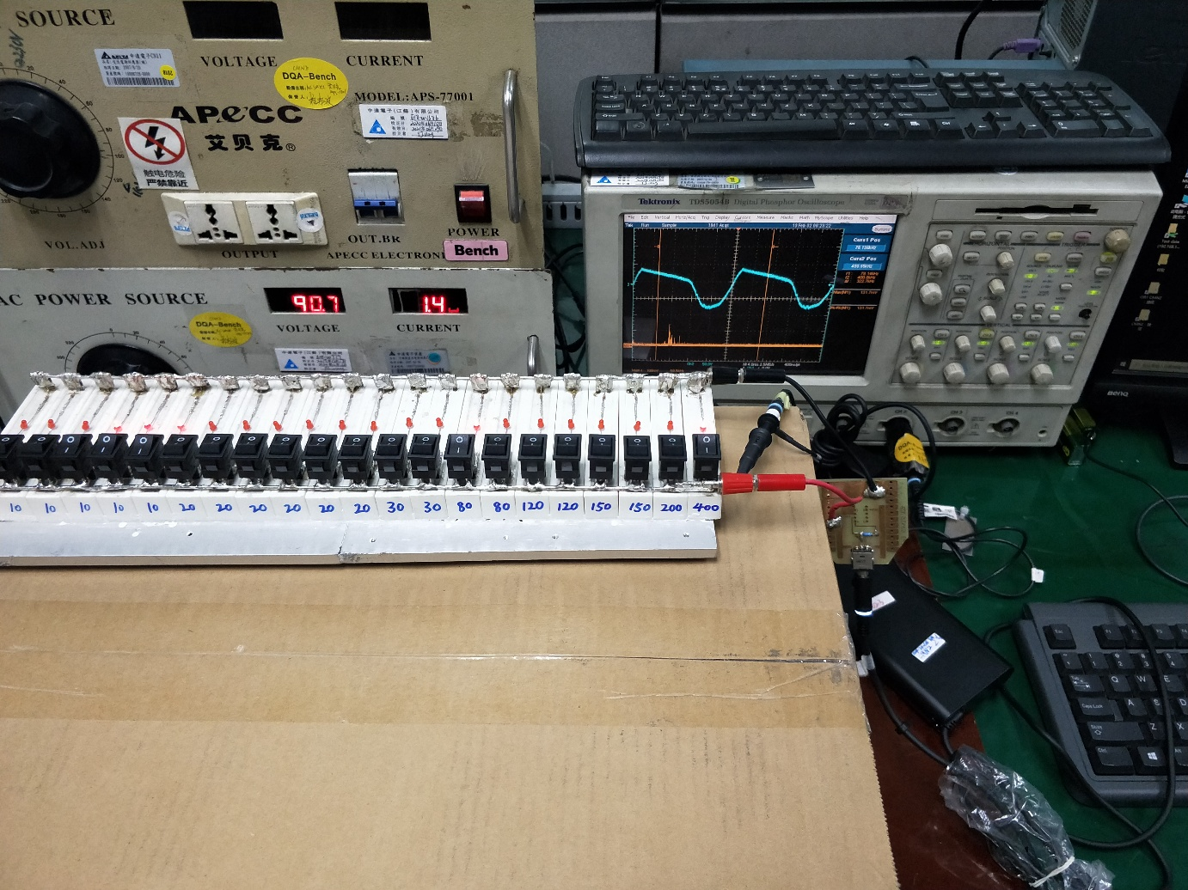
LOAD 需用纸箱架高台面15CM
水泥负载
Test sample
Ac Source
测试示波器

- EMI : CISPR 32 : CLASS B under 6db with resistive load, Remark:廠內若有頻段不足內規,可再經由CL,中達科研中心確認或由DELL lab 判定.
- RFI : CLASS B under 6db with resistive load, Remark:廠內若有頻段不足內規,可再經由確認CL,中達科研中心確認或由DELL lab 判定.
- Case temp 90Vac/60hz<=95 deg/C 5 face.
- Acoustic noise follow 100~20KHZ<=30dB 標準進行判定 base on condition for DELL SQ

